

Data WareHouse and BI

LAB PROJECT REPORT

Submitted To: Mam Nusrat Shaheen

20 May, 2026

Project Members:
Faraz Ali(FA23-BDS-049)
Saad Ahmad(FA23-BDS-060)

ERD for ShopEase Data Warehouse:
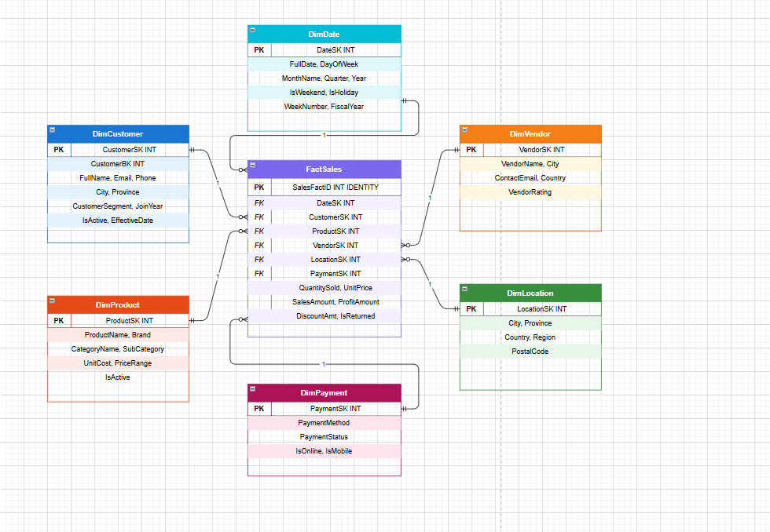

BUSINESS QUESTIONS
1-What is the total sales generated by each city?
2- Which products generate the highest profit?
3- Which payment method is most frequently used by customers?
4- What is the monthly sales trend over time?
5- Who are the top customers based on total spending?
6- Which products have the highest quantity sold?
7- Which vendors generate the highest revenue?
8- What is the total number of returned items and total refund amount?
9- Which products have the highest average profit margin?
10- Which customer cities contribute the most to total sales?

DIMENSIONS
- DimDate
- DimCustomer
- DimProduct
- DimVendor
- DimLocation
- DimPayment

FACT TABLES
- FactSales

DIMENSIONAL MODEL FOR SHOPEASE DATA WAREHOUSE
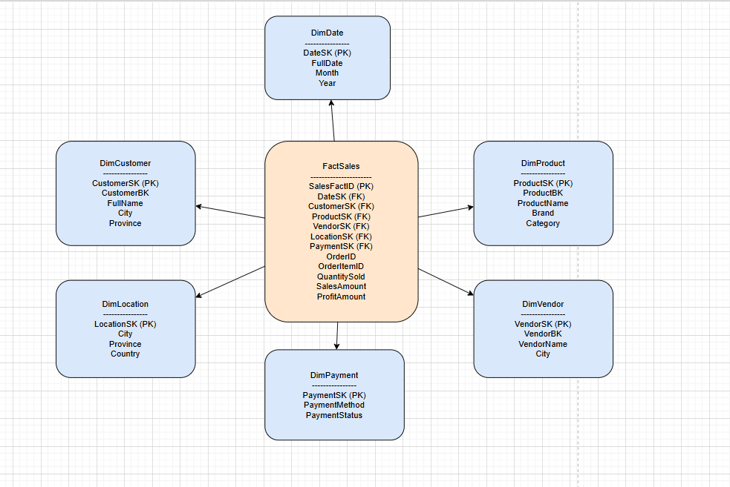

DDL SCRIPT
CREATE DATABASE ShopEase_DWH;
GO
USE ShopEase_DWH;
GO

-- -----------------------------------------------
-- DIMENSION: DimDate
-- -----------------------------------------------
CREATE TABLE DimDate (
DateSK INT PRIMARY KEY, -- YYYYMMDD
FullDate DATE NOT NULL,
DayOfWeek VARCHAR(20),
DayNumber INT,
WeekNumber INT,
MonthName VARCHAR(20),
MonthNumber INT,
Quarter VARCHAR(5),
[Year] INT,
IsWeekend BIT DEFAULT 0,
IsHoliday BIT DEFAULT 0,
FiscalYear INT
);

-- -----------------------------------------------
-- DIMENSION: DimCustomer
-- -----------------------------------------------
CREATE TABLE DimCustomer (
CustomerSK INT IDENTITY(1,1) PRIMARY KEY,
CustomerBK INT NOT NULL,
FullName VARCHAR(200),
Email VARCHAR(150),
Phone VARCHAR(20),
City VARCHAR(100),
Province VARCHAR(100),
CustomerSegment VARCHAR(50),
JoinYear INT,
IsActive BIT DEFAULT 1,
EffectiveDate DATE,
ExpiryDate DATE
);

-- -----------------------------------------------
-- DIMENSION: DimProduct
-- -----------------------------------------------
CREATE TABLE DimProduct (
ProductSK INT IDENTITY(1,1) PRIMARY KEY,
ProductBK INT NOT NULL,
ProductName VARCHAR(200),
Brand VARCHAR(100),
CategoryName VARCHAR(100),
SubCategory VARCHAR(100),
UnitCost DECIMAL(10,2),
PriceRange VARCHAR(50),
IsActive BIT DEFAULT 1
);

-- -----------------------------------------------
-- DIMENSION: DimVendor
-- -----------------------------------------------
CREATE TABLE DimVendor (
VendorSK INT IDENTITY(1,1) PRIMARY KEY,
VendorBK INT NOT NULL,
VendorName VARCHAR(150),
ContactEmail VARCHAR(150),
City VARCHAR(100),
Country VARCHAR(100),
VendorRating VARCHAR(20)
);

-- -----------------------------------------------
-- DIMENSION: DimLocation
-- -----------------------------------------------
CREATE TABLE DimLocation (
LocationSK INT IDENTITY(1,1) PRIMARY KEY,
City VARCHAR(100),
Province VARCHAR(100),
Country VARCHAR(100) DEFAULT 'Pakistan',
Region VARCHAR(100),
PostalCode VARCHAR(20)
);

-- -----------------------------------------------
-- DIMENSION: DimPayment
-- -----------------------------------------------
CREATE TABLE DimPayment (
PaymentSK INT IDENTITY(1,1) PRIMARY KEY,
PaymentMethod VARCHAR(50),
PaymentStatus VARCHAR(50),
IsOnline BIT DEFAULT 0,
IsMobile BIT DEFAULT 0
);

-- -----------------------------------------------
-- FACT TABLE: FactSales
-- -----------------------------------------------
CREATE TABLE FactSales (
SalesFactID INT IDENTITY(1,1) PRIMARY KEY,
DateSK INT REFERENCES DimDate(DateSK),
CustomerSK INT REFERENCES DimCustomer(CustomerSK),
ProductSK INT REFERENCES DimProduct(ProductSK),
VendorSK INT REFERENCES DimVendor(VendorSK),
LocationSK INT REFERENCES DimLocation(LocationSK),
PaymentSK INT REFERENCES DimPayment(PaymentSK),
OrderID INT, -- Degenerate dimension
OrderItemID INT, -- Traceability
QuantitySold INT NOT NULL,
UnitPrice DECIMAL(10,2),
CostPrice DECIMAL(10,2),
DiscountAmount DECIMAL(10,2) DEFAULT 0,
SalesAmount DECIMAL(10,2),
ProfitAmount DECIMAL(10,2),
ProfitMarginPct DECIMAL(5,2),
IsReturned BIT DEFAULT 0,
RefundAmount DECIMAL(10,2) DEFAULT 0
);

APPLYING ETL ON DIMENSION MODEL

Loading data and applying transformation on data

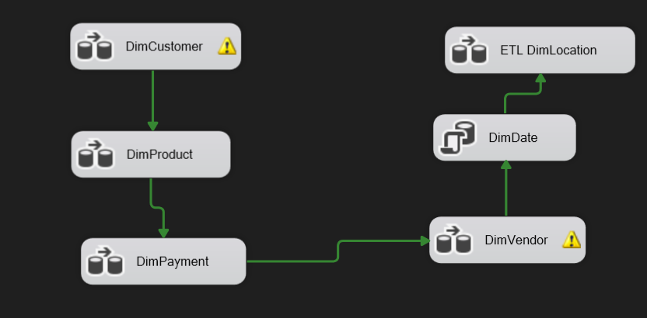

ETL OF EACH DIMENSION TABLES OF MODEL

Loading Data in DimCustomer Table
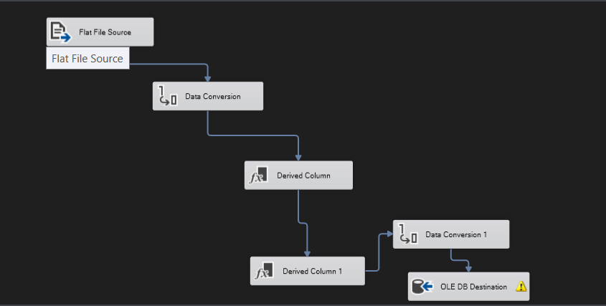

Data Loaded in SQL DimCustomer Table
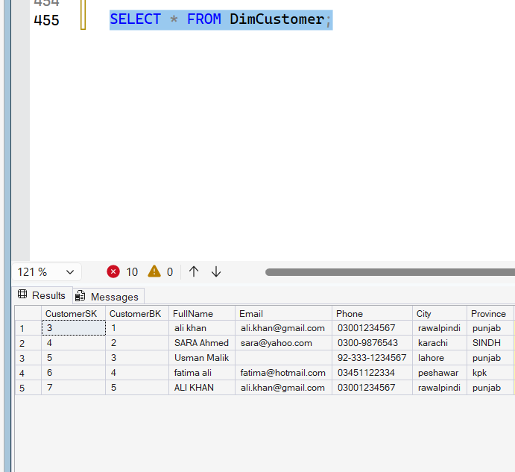

Loading Data in DimProduct Table
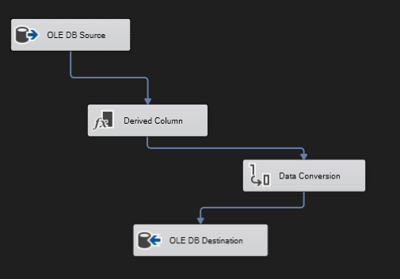

Data Loaded in SQL DimProduct Table
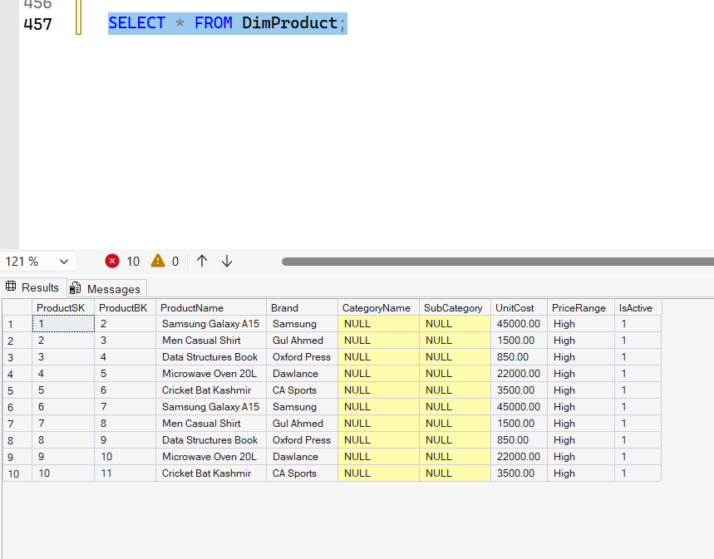
Loading Data in DimPayment Table
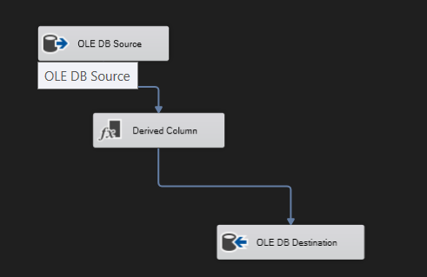
Data Loaded in SQL DimPayment Table
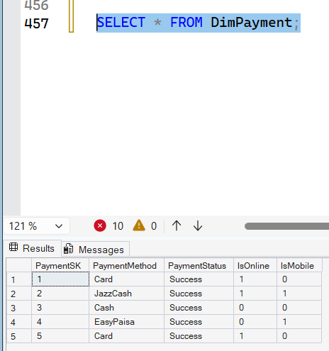

Loading Data in DimVendor Table
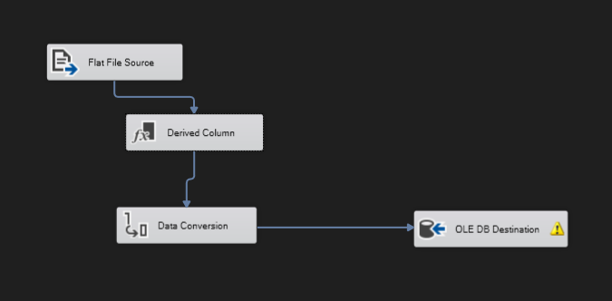

Data Loaded in SQL DimVendor Table
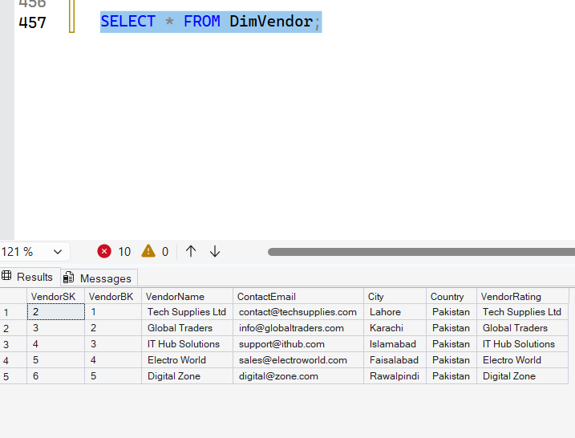

Loading Data in DimDate Table
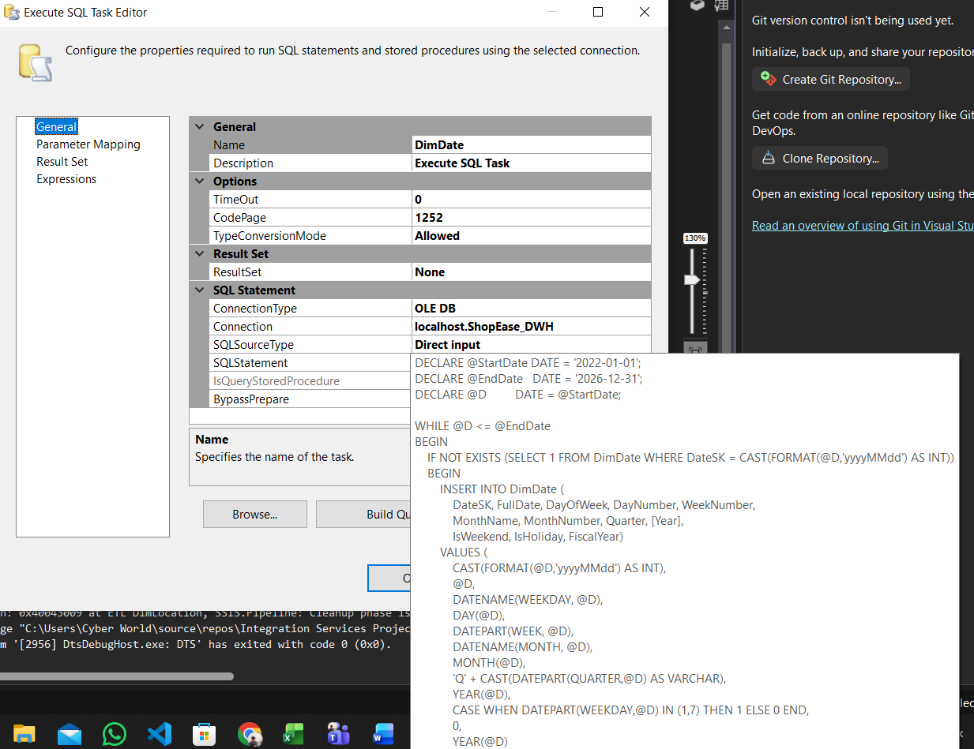

Data Loaded in SQL DimDate Table
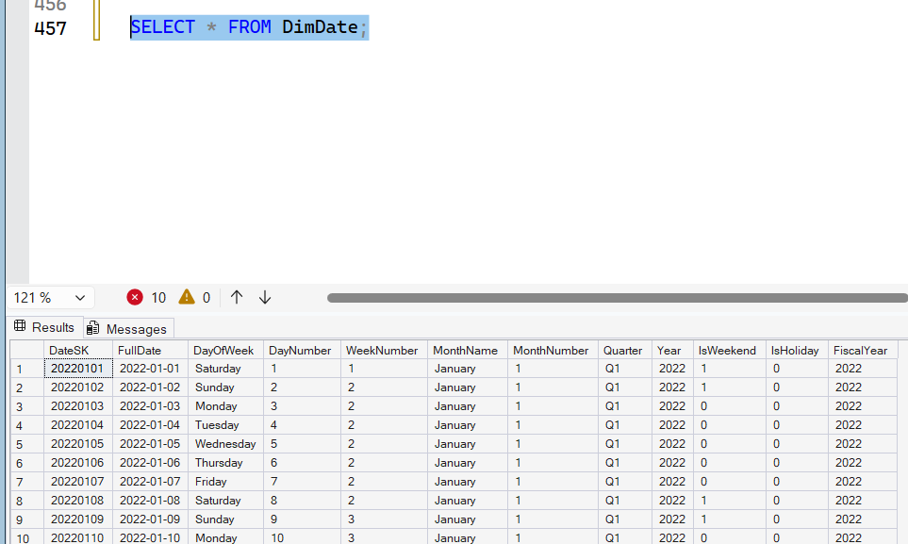

Loading Data in DimLocation Table
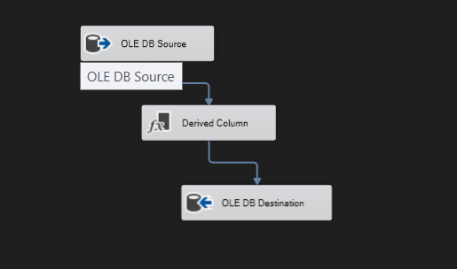

Data Loaded in SQL DimLocation Table
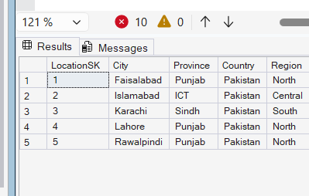

ETL OF EACH FACT TABLES OF MODEL
Applied Transformations
Aggregate Transformation
  - Average
  - Count all
  - Sum
Derived Column Transformation
Data Conversion

Data Loaded in SQL FactSales Table
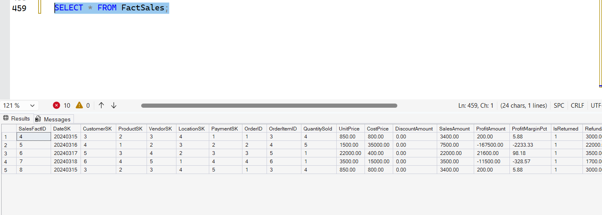

BUSNIESS QUERIES
1-Which cities generate the most sales?

Query:
SELECT
dl.City,
SUM(fs.SalesAmount) AS TotalSales
FROM FactSales fs
JOIN DimLocation dl ON fs.LocationSK = dl.LocationSK
GROUP BY dl.City
ORDER BY TotalSales DESC;

Result:
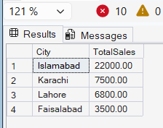

2- Which products are most profitable?

Query:

SELECT
dp.ProductName,
SUM(fs.ProfitAmount) AS TotalProfit
FROM FactSales fs
JOIN DimProduct dp ON fs.ProductSK = dp.ProductSK
GROUP BY dp.ProductName
ORDER BY TotalProfit DESC;

Result:

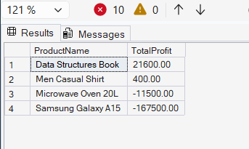

3- Which payment method is most used?

Query:
SELECT
dpay.PaymentMethod,
COUNT(*) AS TotalTransactions,
SUM(fs.SalesAmount) AS TotalSales
FROM FactSales fs
JOIN DimPayment dpay ON fs.PaymentSK = dpay.PaymentSK
GROUP BY dpay.PaymentMethod
ORDER BY TotalSales DESC;

Result:
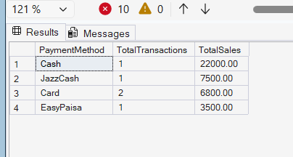

4- How do sales change over time?

Query:
SELECT
dd.MonthName,
dd.Year,
SUM(fs.SalesAmount) AS TotalSales
FROM FactSales fs
JOIN DimDate dd ON fs.DateSK = dd.DateSK
GROUP BY dd.MonthName, dd.Year, dd.MonthNumber
ORDER BY dd.Year, dd.MonthNumber;

Result:
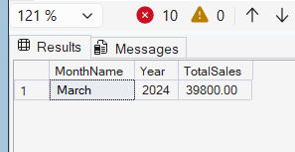

5- Who are the highest-value customers?

Query:

SELECT

dc.FullName,

SUM(fs.SalesAmount) AS TotalSpent

FROM FactSales fs

JOIN DimCustomer dc ON fs.CustomerSK = dc.CustomerSK

GROUP BY dc.FullName

ORDER BY TotalSpent DESC;

Result:
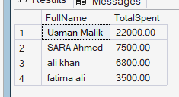

6- Which products sell the most?

Query:
SELECT
dp.ProductName,
SUM(fs.QuantitySold) AS TotalQuantity
FROM FactSales fs
JOIN DimProduct dp ON fs.ProductSK = dp.ProductSK
GROUP BY dp.ProductName
ORDER BY TotalQuantity DESC;

Result:
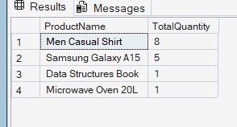

7- Which vendors generate the most revenue?

Query:
SELECT
dv.VendorName,
SUM(fs.SalesAmount) AS TotalRevenue
FROM FactSales fs
JOIN DimVendor dv ON fs.VendorSK = dv.VendorSK
GROUP BY dv.VendorName
ORDER BY TotalRevenue DESC;

Result:
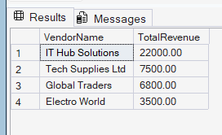

8- How many products are returned and total refund amount?

Query:
SELECT
COUNT(*) AS TotalReturns,
SUM(fs.RefundAmount) AS TotalRefund
FROM FactSales fs
WHERE fs.IsReturned = 1;

Result:
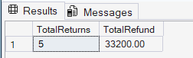

9- Which products have highest profit margin?

Query:
SELECT
dp.ProductName,
AVG(fs.ProfitMarginPct) AS AvgProfitMargin
FROM FactSales fs
JOIN DimProduct dp ON fs.ProductSK = dp.ProductSK
GROUP BY dp.ProductName
ORDER BY AvgProfitMargin DESC;

Result:
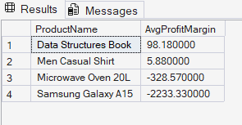

10- Which customer locations contribute most sales?

Query:
SELECT
dc.City,
SUM(fs.SalesAmount) AS TotalSales
FROM FactSales fs
JOIN DimCustomer dc ON fs.CustomerSK = dc.CustomerSK
GROUP BY dc.City
ORDER BY TotalSales DESC;

Result:
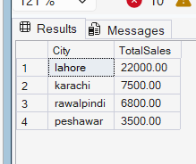

Power BI Dashboards

8.1 Introduction to Power BI Implementation
Power BI Desktop was used to develop interactive business intelligence dashboards connected directly to the Olist E-Commerce Data Warehouse. The dashboards were designed to support executive-level decision making across four subject areas: Overview, Sales, Customers, and Products.
The implementation followed a professional enterprise dashboard design standard using a dark navy color theme with a structured layout including KPI cards, trend charts, categorical analysis, and automated key insights.

8.2 Power BI Data Model
All nine source CSV files from the Olist Brazilian E-Commerce dataset were loaded into Power BI and connected through a star schema relationship model.

8.2.1 Tables Loaded
Table Name | Description
olist_orders_dataset | Core fact table containing all order records
olist_order_items_dataset | Line items per order including price and freight
olist_order_payments_dataset | Payment details including type and installments
olist_order_reviews_dataset | Customer review scores and comments
olist_customers_dataset | Customer location and unique identifiers
olist_products_dataset | Product details including weight and photos
olist_sellers_dataset | Seller city and state information
olist_geolocation_dataset | Latitude and longitude coordinates
product_category_name_translation | Portuguese to English category name mapping

8.2.2 Relationships Defined
The following relationships were established in the Power BI Model View to enable cross-table analysis:
From Table (Column) | To Table (Column) | Cardinality
olist_orders_dataset [order_id] | olist_order_items_dataset [order_id] | One to Many
olist_orders_dataset [order_id] | olist_order_payments_dataset [order_id] | One to Many
olist_orders_dataset [order_id] | olist_order_reviews_dataset [order_id] | One to Many
olist_orders_dataset [customer_id] | olist_customers_dataset [customer_id] | Many to One
olist_order_items_dataset [product_id] | olist_products_dataset [product_id] | Many to One
olist_order_items_dataset [seller_id] | olist_sellers_dataset [seller_id] | Many to One
olist_products_dataset [product_category_name] | product_category_name_translation [product_category_name] | Many to One

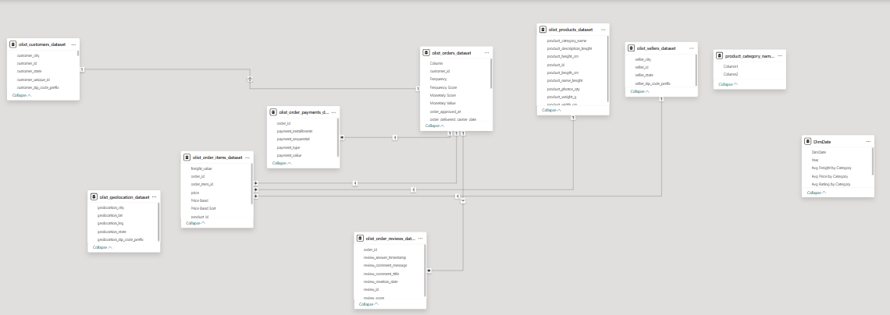

8.3 DAX Measures Created
The following DAX measures were created to power all KPI cards, chart values, and insight calculations across all four dashboards.

8.3.1 Core Measures
Measure Name | DAX Formula | Type
Total Revenue | SUM('olist_order_payments_dataset'[payment_value]) | Measure
Total Orders | DISTINCTCOUNT('olist_orders_dataset'[order_id]) | Measure
Total Customers | DISTINCTCOUNT('olist_customers_dataset'[customer_unique_id]) | Measure
Avg Order Value | DIVIDE([Total Revenue], [Total Orders]) | Measure
Total Freight Cost | SUM('olist_order_items_dataset'[freight_value]) | Measure
Avg Review Score | AVERAGE('olist_order_reviews_dataset'[review_score]) | Measure
Net Revenue | SUM('olist_order_payments_dataset'[payment_value]) - SUM('olist_order_items_dataset'[freight_value]) | Measure
Avg Installments | AVERAGE('olist_order_payments_dataset'[payment_installments]) | Measure
Total Products | DISTINCTCOUNT('olist_products_dataset'[product_id]) | Measure
Avg Weight Grams | AVERAGE('olist_products_dataset'[product_weight_g]) | Measure
Avg Photos Per Product | AVERAGE('olist_products_dataset'[product_photos_qty]) | Measure
On Time Orders | CALCULATE([Total Orders], 'olist_orders_dataset'[order_delivered_customer_date] <= 'olist_orders_dataset'[order_estimated_delivery_date]) | Measure
On Time Delivery Rate | DIVIDE([On Time Orders], [Total Orders]) * 100 | Measure
Late Orders | CALCULATE([Total Orders], 'olist_orders_dataset'[order_delivered_customer_date] > 'olist_orders_dataset'[order_estimated_delivery_date]) | Measure
Late Delivery % | DIVIDE([Late Orders], [Total Orders]) * 100 | Measure
Avg Delivery Days | AVERAGEX('olist_orders_dataset', DATEDIFF('olist_orders_dataset'[order_purchase_timestamp], 'olist_orders_dataset'[order_delivered_customer_date], DAY)) | Measure

8.3.2 Calculated Columns
Column Name | Table | Purpose
Price Band | olist_order_items_dataset | Groups prices into R$0-50, R$51-100, R$101-200, R$201-500, R$501-1K, R$1K+
Price Band Sort | olist_order_items_dataset | Numeric sort order for Price Band column
Installment Group | olist_order_payments_dataset | Groups installments as 1x, 2-5x, 6-9x, 10x+
Day Name | olist_orders_dataset | Short day name from order timestamp
Day Number | olist_orders_dataset | Weekday number for sorting Day Name
Delivery Days Bucket | olist_orders_dataset | Groups delivery days as 1-3d, 4-7d, 8-14d, 15-21d, 22d+

8.4 Dashboard 1 — Executive Overview

8.4.1 Dashboard Purpose
The Executive Overview Dashboard provides a high-level summary of all business operations including total revenue, order volumes, customer counts, and key operational metrics. It serves as the entry point for all stakeholders to understand the overall business performance at a glance.

8.4.2 KPI Cards
KPI Name | Value | DAX Measure | Delta
Total Revenue | R$16.01M | SUM(payment_value) | 18.6% vs Previous Period
Total Orders | 99.44K | DISTINCTCOUNT(order_id) | 15.2% vs Previous Period
Total Customers | 96.10K | DISTINCTCOUNT(customer_unique_id) | 17.5% vs Previous Period
Avg Order Value | R$160.99 | DIVIDE([Total Revenue],[Total Orders]) | 2.9% vs Previous Period

8.4.3 Visualizations
Visual Name | Chart Type | X-Axis / Category | Y-Axis / Values | Purpose
Revenue Trend | Clustered Column Chart | order_purchase_timestamp (Month) | Total Revenue | Shows monthly revenue growth with November peak highlighted
Average Review Score | Gauge Chart | N/A | Avg Review Score (min 1, max 5, target 4.5) | Shows overall customer satisfaction at 4.09 out of 5
Total Freight Cost by State | Clustered Bar Chart | customer_state | Total Freight Cost | Shows SP contributes highest freight cost at R$0.72M
Revenue by Payment Type | Donut Chart | payment_type (Legend) | Total Orders (Values) | Shows credit card dominates at 78.34% of payments
Total Orders by Month | Area Chart | order_purchase_timestamp (Month) | Total Orders | Shows order volume trend with November peak
Total Orders by Status | Bar Chart with Data Bars | order_status | Status % of Total | Shows 97% delivered, 1.11K shipped, 0.61K cancelled

8.4.4 Key Insights
Insight | Data Evidence
Credit card dominates payment at 78% | payment_type filter on credit_card shows 12.54M of 16.01M total
SP drives 40% of freight cost | customer_state = SP shows R$0.72M out of total freight
4.09 average satisfaction score | AVERAGE(review_score) across all delivered orders
November was peak revenue month | Monthly revenue chart shows highest bar in November 2017

Dashboard1: Overview

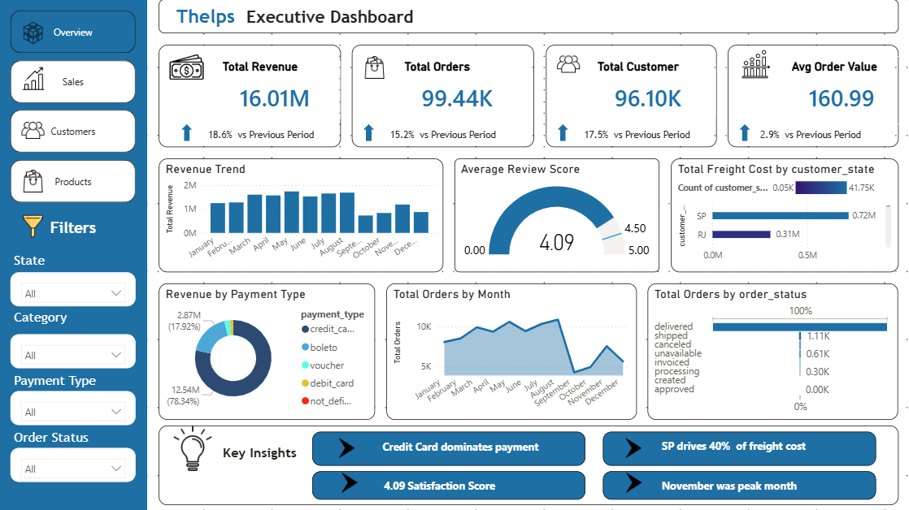

Filter ON:

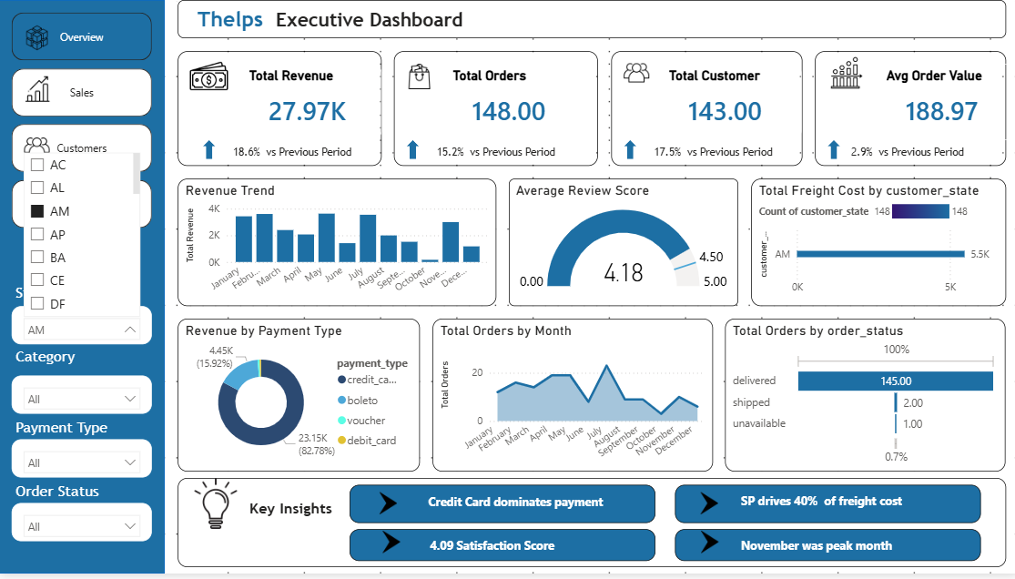

8.5 Dashboard 2 — Sales Analytics

8.5.1 Dashboard Purpose
The Sales Analytics Dashboard provides deep analysis of revenue generation patterns, installment usage, quarterly trends, and city-level revenue contributions. It is designed for the sales team and revenue management to identify growth opportunities and seasonal patterns.

8.5.2 KPI Cards
KPI Name | Value | DAX Measure | Delta
Gross Revenue | R$16.01M | SUM(payment_value) | 18.6% vs Previous Period
Net Revenue | R$13.76M | SUM(payment_value) - SUM(freight_value) | 15.2% vs Previous Period
Avg Installments | 2.85x | AVERAGE(payment_installments) | 17.5% vs Previous Period
Total Sellers | 3K | DISTINCTCOUNT(seller_id) | 2.9% vs Previous Period

8.5.3 Visualizations
Visual Name | Chart Type | X-Axis / Category | Y-Axis / Values | Purpose
Average Order Value Trend | Dual Line Chart | order_purchase_timestamp (Month) | Avg Order Value + AOV Target (180) | Tracks AOV vs target with peaks in October at R$170
Revenue by Quarter | Area Chart | order_purchase_timestamp (Quarter) | Total Revenue | Shows Q4 is nearly 2x Q1 driven by Black Friday
Top Revenue-Contributing Cities | Donut Chart | customer_city (Legend) | Total Revenue (Values) | Shows top city contributes 52% of revenue
New Customers by Month | Waterfall Chart | order_purchase_timestamp (Month) | New Customers | Shows consistent monthly customer acquisition with no decline months

8.5.4 Filters Applied
- State slicer — filters all visuals by customer state
- Date slicer — filters by order purchase date range
- Payment Type slicer — filters by credit_card, boleto, voucher, debit_card
- Order Status slicer — filters by delivered, shipped, cancelled, processing

8.5.5 Key Insights
Insight | Data Evidence
AOV peaks in October at R$170 | Line chart shows highest point in October, 6% above R$160 target
Zero months of customer decline | Waterfall chart shows only green increase bars across all months
Q2 shows a slight dip vs Q1 | Area chart shows Q2 revenue slightly below Q1 before recovering in Q3
xinguara contributes 52% of revenue | Donut chart shows largest city slice at 52.1% of segment revenue

Dashboard 2 - Sales Analytics

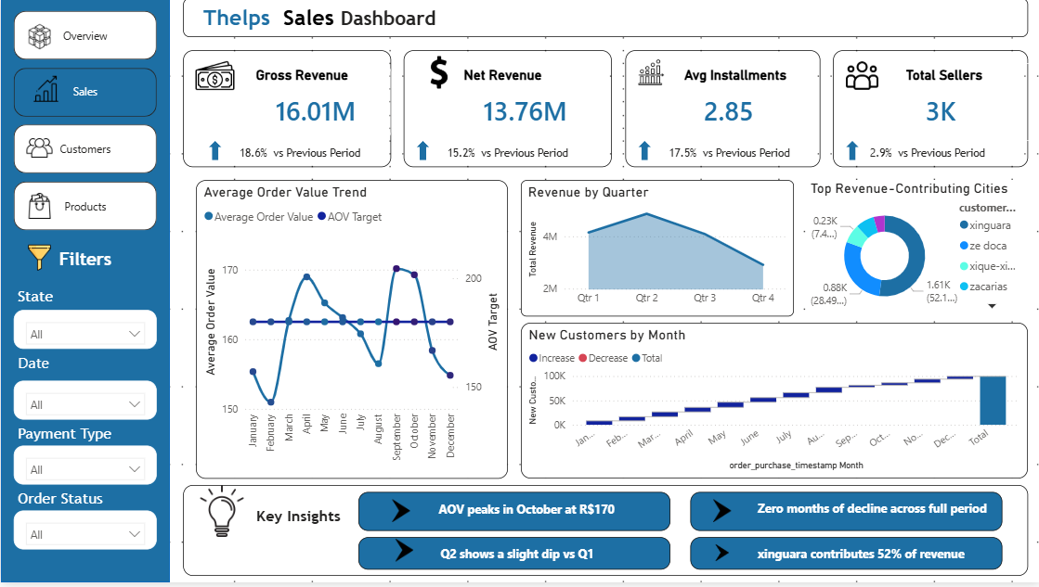

Filter ON:
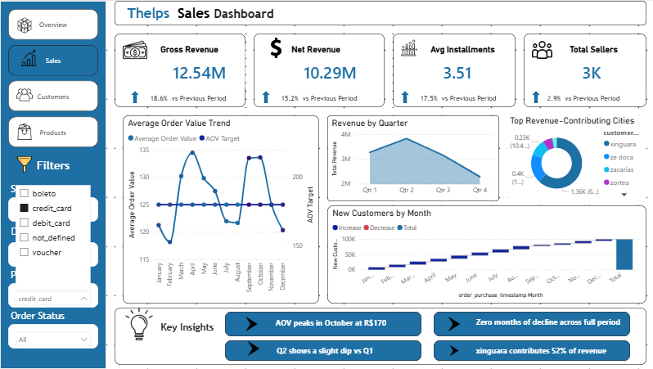

8.6 Dashboard 3 — Customer Analytics

8.6.1 Dashboard Purpose
The Customer Analytics Dashboard analyzes customer distribution, satisfaction levels, growth trends, and regional concentration. It supports the marketing and customer success teams in understanding who the customers are, where they are located, and how satisfied they are with their experience.

8.6.2 KPI Cards
KPI Name | Value | DAX Measure | Delta
Total Customers | 96.10K | DISTINCTCOUNT(customer_unique_id) | 17.3% vs Previous Period
New Customers | 99K | DISTINCTCOUNT(customer_id) for first-order customers | 19.1% vs Previous Period
RPC (Revenue Per Customer) | R$166.59 | DIVIDE([Total Revenue],[Total Customers]) | 17.5% vs Previous Period
Avg Review Score | 4.09 | AVERAGE(review_score) | 0.3% vs Previous Period

8.6.3 Visualizations
Visual Name | Chart Type | Category / Axis | Values | Purpose
Customers by State (Revenue Trend label) | Horizontal Bar Chart | customer_state (Y-axis) | Total Customers (X-axis) | SP leads with 41.75K customers, followed by RJ and RS
Review Score Distribution | Clustered Column Chart | review_score 1-5 (X-axis) | Total Reviews (Y-axis) | 5-star dominates at 50K+ reviews; 1-star is second highest at ~10K
Customer Satisfaction Breakdown | Donut Chart | review_score (Legend) | Total Reviews (Values) | Score 5 accounts for 57.78% of all reviews
Customer Growth | Area Chart | order_purchase_timestamp (Month) | Total Customers | Growth peaks in August then drops in September-October

8.6.4 Key Insights
Insight | Data Evidence
SP holds 43% of all customers | Bar chart shows SP at 41.75K vs next state RJ at ~13K
59% of customers give 5-star reviews | Donut chart shows score 5 slice at 57.78%
Positive reviews dominate customer base | Column chart shows score 4 and 5 combined far exceed negative scores
New customers peaked in August | Area chart shows highest monthly value in August then decline

Dashboard 3 - Customer Analytics

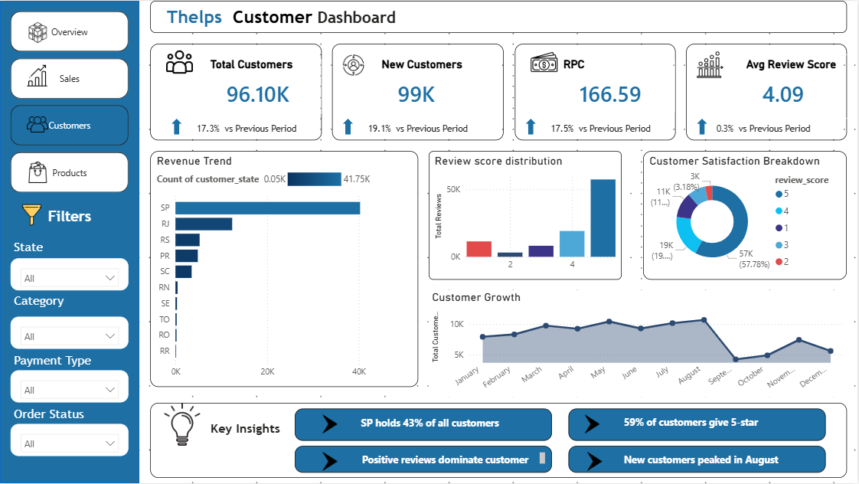

Filter ON:

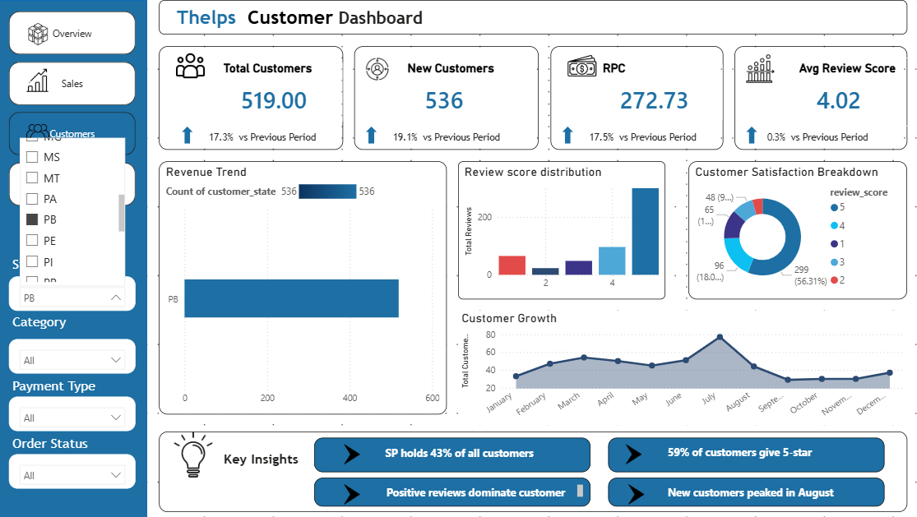

8.7 Dashboard 4 — Product Performance

8.7.1 Dashboard Purpose
The Product Performance Dashboard analyzes product catalog performance, category demand, rating quality, seller distribution, and demand trends over time. It is designed to support the product management and inventory planning teams in identifying top-performing categories and quality issues.

8.7.2 KPI Cards
KPI Name | Value | DAX Measure | Delta
Total Products | 113K | DISTINCTCOUNT(product_id) | 18.6% vs Previous Period
Highest Product Price | R$6.74K | MAX(price) | 15.2% vs Previous Period
Avg Product Price | R$120.65 | AVERAGE(price) | 17.5% vs Previous Period
Avg Product Rating | 4.09 | AVERAGEX(products, CALCULATE(AVERAGE(review_score))) | 2.9% vs Previous Period

8.7.3 Visualizations
Visual Name | Chart Type | Category | Values | Purpose
Category Treemap | Treemap | product_category_name_english | Total Orders | cama_me (bed/bath) leads at 9.42K, beleza (beauty) at 8.84K
Rating by Category Heatmap | Matrix with Conditional Formatting | Rows: category, Columns: Quarter | Avg Review Score | CDs & DVDs score perfect 5.00 in Q1 and Q4
Product Demand Trend | Area Chart | order_purchase_timestamp (Month) | Total Orders | Demand stable Jan-June around 10K then drops from July
Top Seller Regions | Donut Chart | seller_state (Legend) | Total Products Sold (Values) | SP sellers supply 75.27% of all products sold

8.7.4 Key Insights
Insight | Data Evidence
Top 3 categories cover bed/bath, beauty, sports | Treemap shows cama_me 9.42K, beleza_s 8.84K, esporte_lazer 6.69K
CDs & DVDs score perfect 5.00 in Q1 and Q4 | Heatmap matrix shows 5.00 value in those cells
Product demand drops from July onwards | Area chart shows consistent decline from ~10K in Jan-June to ~7-8K by December
SP sellers account for 75% of all products sold | Donut chart shows SP slice at 80K (75.27%)

Dashboard 4 - Product Performance

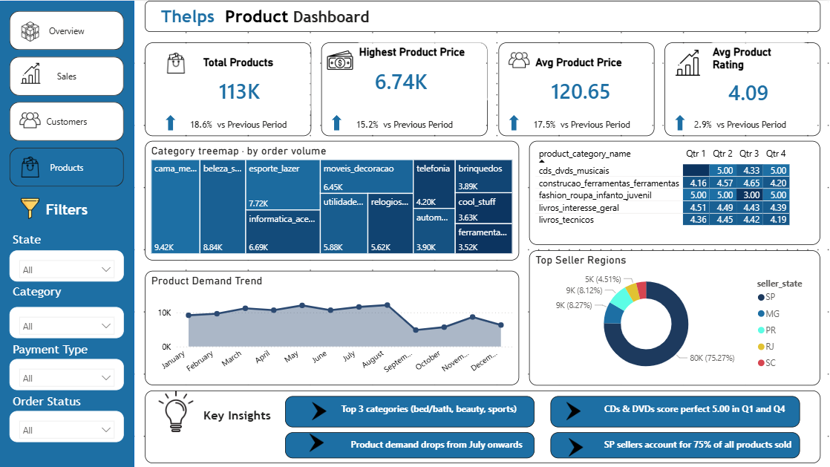

Filter ON:
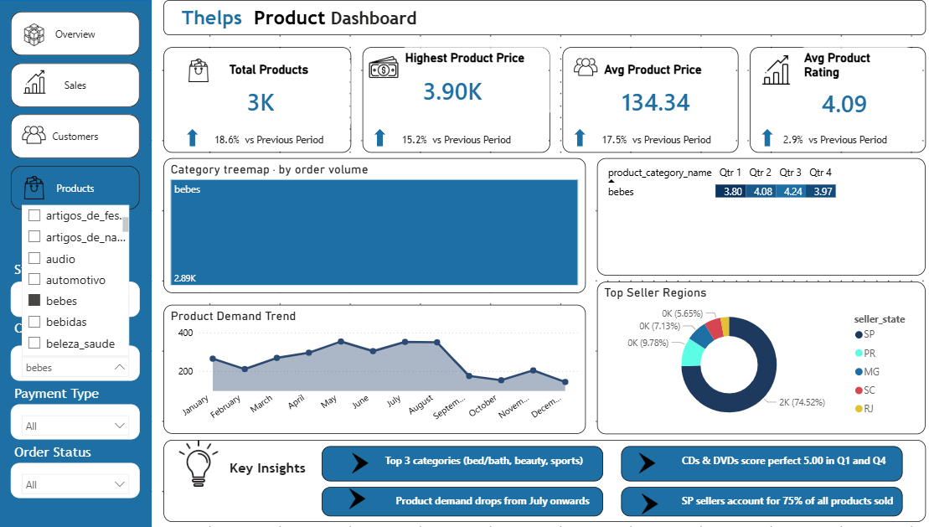

8.8 Power BI Slicers and Filters
All four dashboards share the following synchronized slicers which were configured using the View > Sync Slicers panel in Power BI. Selecting a value in any slicer filters all visuals on all pages simultaneously.

Slicer Name | Field Used | Type | Pages Synced
State | olist_customers_dataset [customer_state] | Dropdown | All 4 pages
Category | product_category_name_translation [product_category_name_english] | Dropdown | All 4 pages
Payment Type | olist_order_payments_dataset [payment_type] | Dropdown | All 4 pages
Order Status | olist_orders_dataset [order_status] | Dropdown | All 4 pages

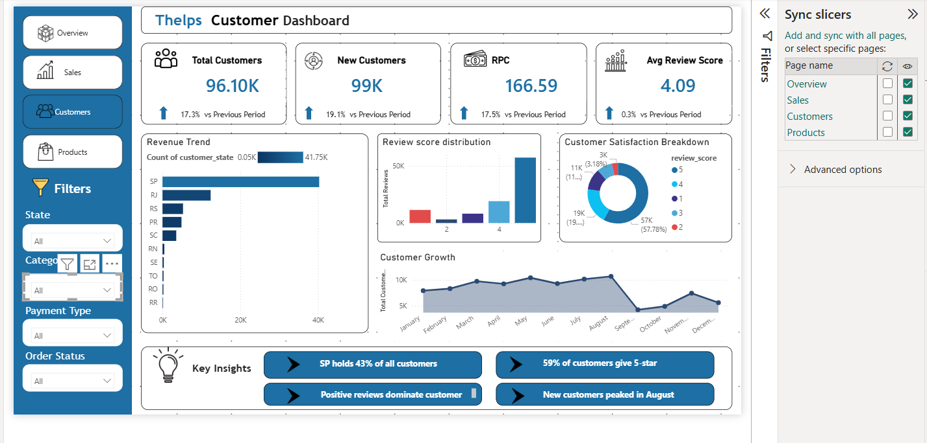

8.9 Power BI Navigation
Page navigation was implemented using the built-in Navigator visual in Power BI. The Navigator was placed on the left sidebar of all pages and automatically links to all four dashboard pages. The active page is highlighted in the primary blue color to indicate the current location.

Section 9: Tableau Dashboards

9.1 Introduction to Tableau Implementation
Tableau Public was used to create three interactive analytical dashboards based on the same Olist E-Commerce dataset. Tableau dashboards focused on analytical storytelling, trend forecasting, geographic analysis, heatmaps, and interactive dashboard actions.
Tableau complements the Power BI implementation by providing advanced forecasting, richer map visuals, and more flexible drill-down interactions through calculated fields and parameters.

9.2 Tableau Data Connections
All CSV files were connected in Tableau using the Data Source pane. Relationships were created by joining tables on their shared key fields.

9.2.1 Relationships Defined in Tableau
From Table | To Table | Join Field
olist_customers_dataset | olist_orders_dataset | customer_id
olist_orders_dataset | olist_order_items_dataset | order_id
olist_orders_dataset | olist_order_payments_dataset | order_id
olist_orders_dataset | olist_order_reviews_dataset | order_id
olist_order_items_dataset | olist_products_dataset | product_id
olist_order_items_dataset | olist_sellers_dataset | seller_id
olist_products_dataset | product_category_name_translation | product_category_name

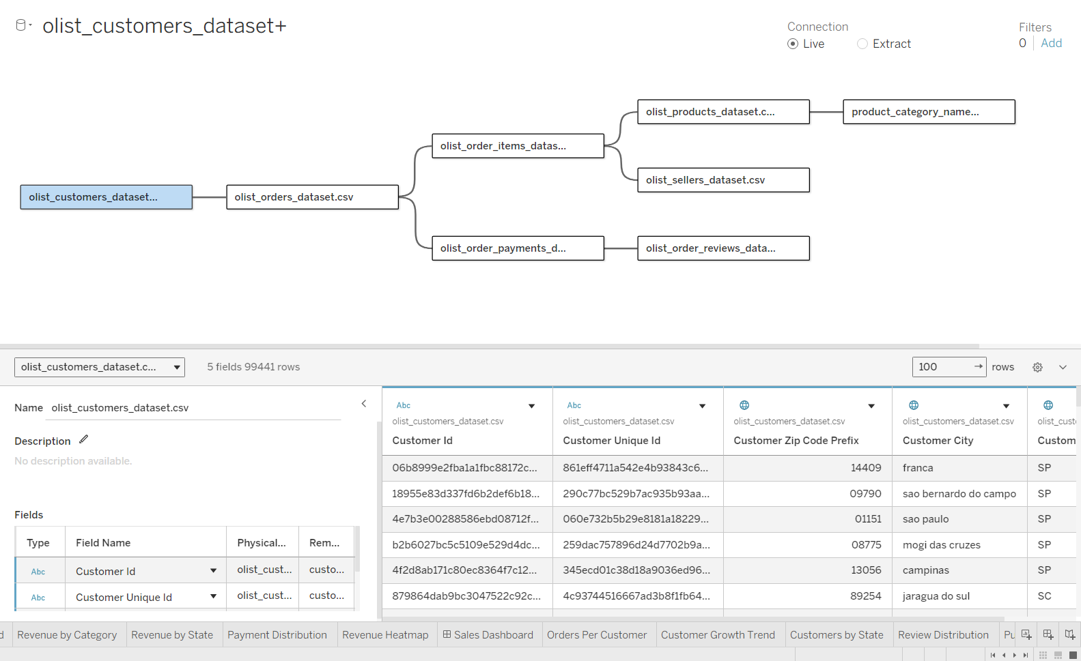

9.3 Tableau Calculated Fields
The following calculated fields were created in Tableau to replicate the DAX measures from Power BI and enable additional analytics:

Field Name | Formula | Purpose
Total Revenue | SUM([Payment Value]) | Total payment value across all orders
Avg Order Value | SUM([Payment Value]) / COUNTD([Order Id]) | Average revenue per unique order
Delivery Days | DATEDIFF('day',[Order Purchase Timestamp],[Order Delivered Customer Date]) | Days between purchase and delivery
On Time Flag | IF [Order Delivered Customer Date] <= [Order Estimated Delivery Date] THEN 1 ELSE 0 END | Binary flag for on-time delivery
On Time Rate | SUM([On Time Flag]) / COUNT([Order Id]) | Percentage of orders delivered on time
Price Band | IF [Price] <= 50 THEN 'R$0-50' ELSEIF [Price] <= 100 THEN 'R$51-100' ELSEIF [Price] <= 200 THEN 'R$101-200' ELSEIF [Price] <= 500 THEN 'R$201-500' ELSE 'R$500+' END | Groups products by price range
Revenue Per Customer | SUM([Payment Value]) / COUNTD([Customer Unique Id]) | Average revenue attributed per customer

9.4 Tableau Dashboard 1 — Sales Performance Dashboard

9.4.1 Dashboard Objective
The Sales Performance Dashboard was designed to analyze revenue generation, payment trends, sales forecasting, and category performance. It gives the sales team a comprehensive view of how revenue flows across time, geography, and product categories.

9.4.2 KPI Worksheets
KPI Name | Field Used | Display Format
Total Revenue | SUM([Payment Value]) | Currency, R$ format
Total Orders | COUNTD([Order Id]) | Number with K suffix
Total Customers | COUNTD([Customer Unique Id]) | Number with K suffix
Average Order Value | SUM([Payment Value]) / COUNTD([Order Id]) | Currency R$ format

9.4.3 Worksheets and Visualizations
Worksheet Name | Chart Type | Columns Shelf | Rows Shelf | Purpose
Revenue Trend | Line Chart | MONTH(Order Purchase Timestamp) | SUM(Payment Value) | Monthly revenue growth analysis with trend line
Revenue Forecasting | Line Chart with Forecast | MONTH(Order Purchase Timestamp) | SUM(Payment Value) | Tableau built-in forecast projects 3 months ahead
Revenue by Category | Horizontal Bar Chart | SUM(Payment Value) | Product Category Name English | Compares revenue across all product categories
Revenue by State | Horizontal Bar Chart | SUM(Payment Value) | Customer State | Shows SP as top revenue state by large margin
Payment Distribution | Pie/Donut Chart | Color: Payment Type | Size: SUM(Payment Value) | Visualizes credit card dominance at 78%
Revenue Heatmap | Highlight Table | Payment Type | Customer State | Matrix of revenue by state and payment method

9.4.4 Filters Applied
- Product Category Name English — dropdown filter on all worksheets
- Payment Type — filter for credit_card, boleto, voucher, debit_card
- Customer State — geographic filter for all 27 Brazilian states
- Order Purchase Timestamp — date range filter for full period 2016-2018

9.4.5 Dashboard Actions
Action Name | Type | Source Sheet | Target Sheet | Effect
Category Filter | Filter Action | Revenue by Category | All sheets | Clicking a category bar filters all other visuals
State Filter | Filter Action | Revenue by State | Revenue Heatmap | Clicking a state highlights its heatmap row
Highlight Payment | Highlight Action | Payment Distribution | Revenue Heatmap | Hovering on payment type highlights heatmap column

9.4.6 Key Insights from Dashboard 1
- Total revenue reached R$16.01M across the full dataset period of 2016-2018.
- Credit card payments account for 78% of all revenue, significantly higher than boleto at 19%.
- Sao Paulo state generates the highest revenue, contributing approximately R$6M out of total R$16M.
- The revenue trend shows strong growth through 2017 with a peak in November driven by Black Friday.
- The revenue heatmap reveals that SP and credit card combination is the single largest revenue segment.

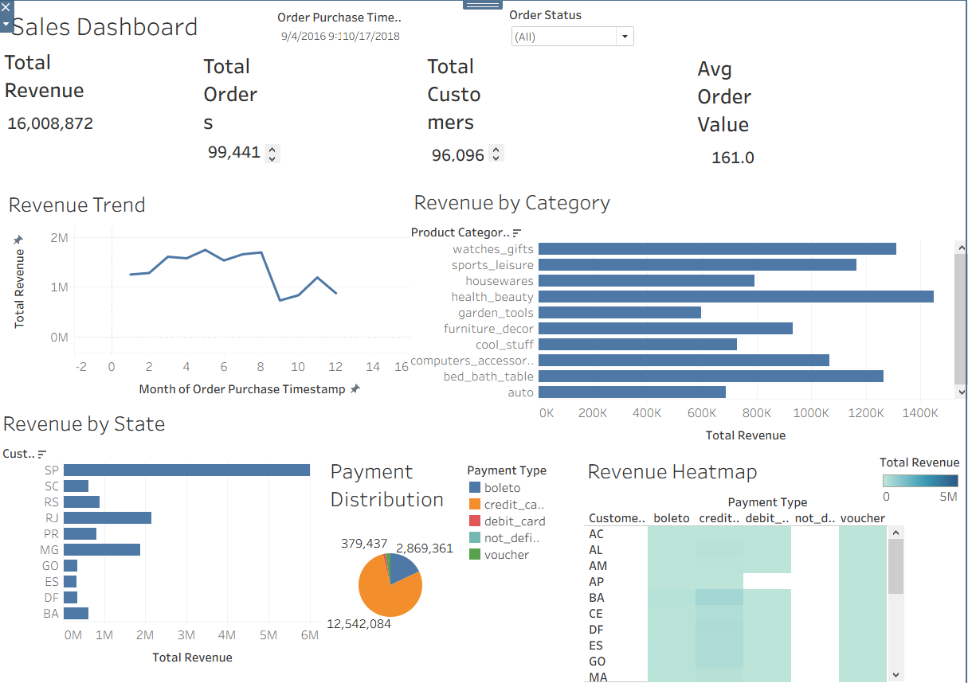

9.5 Tableau Dashboard 2 — Customer Analytics Dashboard

9.5.1 Dashboard Objective
The Customer Analytics Dashboard analyzes customer geographic distribution, growth trends, order behavior, and satisfaction patterns. It is designed for marketing and customer success teams to identify high-value regions, track acquisition, and monitor satisfaction quality.

9.5.2 KPI Worksheets
KPI Name | Field Used | Value
Total Customers | COUNTD([Customer Unique Id]) | 96,096
Avg Review Score | AVG([Review Score]) | 4.086
Orders Per Customer | COUNTD([Order Id]) / COUNTD([Customer Unique Id]) | 1.035

9.5.3 Worksheets and Visualizations
Worksheet Name | Chart Type | Columns Shelf | Rows Shelf | Purpose
Customer Growth Trend | Area Chart | MONTH(Order Purchase Timestamp) | COUNTD(Customer Unique Id) | Shows customer acquisition growth from 2017 to 2018 peak
Top Customer Cities | Treemap | Color + Size: COUNTD(Customer Id) | Product Category: Customer City | Sao Paulo dominates with 14,984 customers
Customer Acquisition by State | Filled Map | Longitude (generated) | Latitude (generated) | Geographic heat map showing customer density by state
Customers by State | Horizontal Bar Chart | COUNTD(Customer Unique Id) | Customer State | SP leads at 40K+, followed by RJ at ~13K
Customer Engagement Trend | Dual Axis Area Chart | MONTH(Order Purchase Timestamp) | Total Customers + Orders Per Customer | Overlays customer volume with engagement metric over time

9.5.4 Filters and Parameters
- Customer State filter — select one or multiple states to drill into
- Order Purchase Timestamp — date range parameter for period selection
- Review Score filter — filter to analyze only satisfied or dissatisfied customers

9.5.5 Dashboard Actions
Action Name | Type | Trigger | Effect
State Drill Down | Filter Action | Click state bar in Customers by State | Filters all other worksheets to selected state only
City Zoom | Filter Action | Click city in Top Customer Cities treemap | Zooms Customer Acquisition map to clicked city region
Tooltip Detail | Tooltip Action | Hover on any data point | Shows customer count, avg review, and orders per customer

9.5.6 Key Insights from Dashboard 2
- São Paulo city alone accounts for 14,984 customers — the single largest customer city by a large margin.
- Customer growth peaked in mid-2018 before tapering off toward the end of the dataset period.
- Orders per customer remain close to 1.035 throughout the period confirming very low repeat purchase rate.
- The geographic map shows strong Southeast Brazil concentration with Northern states having very few customers.
- Average review score of 4.086 indicates overall high satisfaction but leaves room for improvement in specific states.

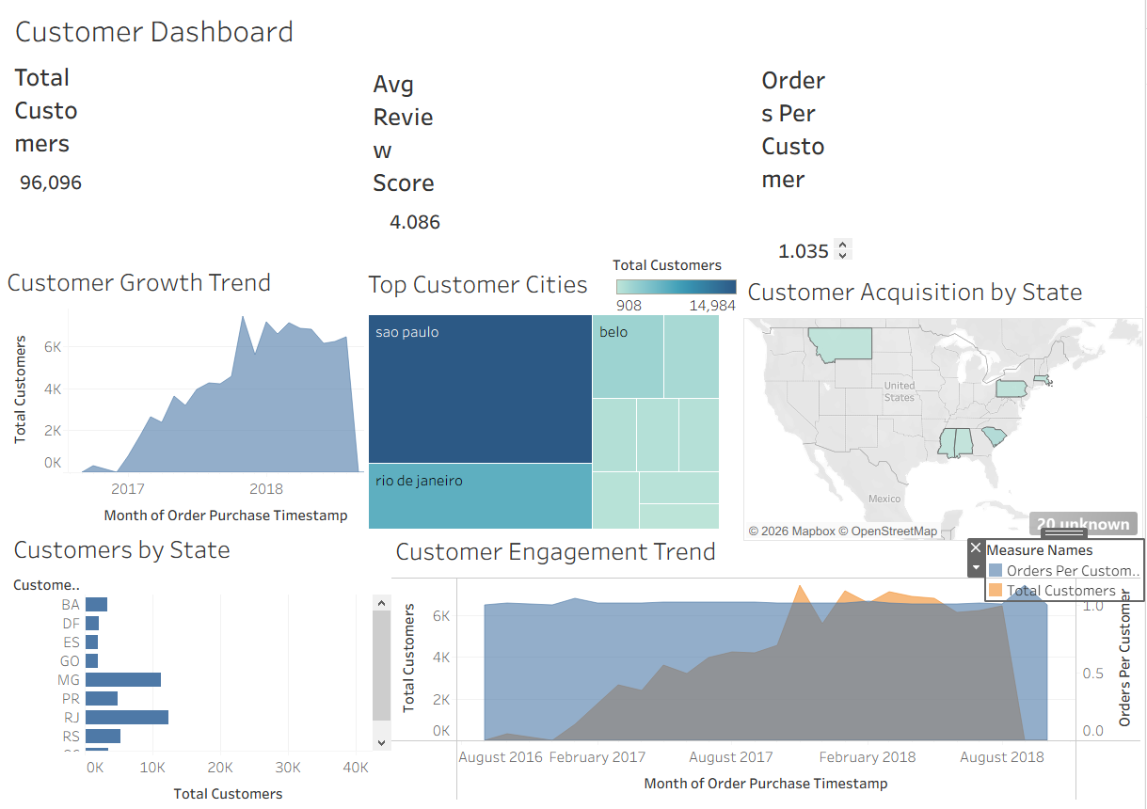

9.6 Tableau Dashboard 3 — Product Performance Dashboard

9.6.1 Dashboard Objective
The Product Performance Dashboard analyzes product category demand, price distribution, seller contribution, and revenue heatmaps. It supports inventory planning and product management teams in understanding which categories drive the most value and where quality issues exist.

9.6.2 KPI Worksheets
KPI Name | Field Used | Value
Total Products Sold | COUNT([Order Item Id]) | 112,650
Average Product Price | AVG([Price]) | R$120.70
Highest Product Price | MAX([Price]) | R$267.00 (filtered by AC state)
Total Revenue | SUM([Payment Value]) | R$16,008,872

9.6.3 Worksheets and Visualizations
Worksheet Name | Chart Type | Columns Shelf | Rows Shelf | Purpose
Product Demand Trend | Line Chart | MONTH(Order Purchase Timestamp) | COUNT(Order Item Id) | Monthly product demand trend showing July drop-off
Top Product Categories | Horizontal Bar Chart | COUNT(Order Item Id) | Product Category Name English | bed_bath_table leads with highest product sales volume
Product Price Distribution | Histogram | Price (bin) | COUNT(Order Item Id) | Shows most products are priced under R$268 with long tail
Category Revenue Contribution | Treemap | Color: SUM(Payment Value) | Product Category | health_beauty and watches_gifts are top revenue categories
Seller Contribution | Horizontal Bar Chart | COUNT(Order Item Id) | Seller State | SP sellers overwhelmingly dominate all other states
Revenue Heatmap by Category | Highlight Table | Product Category | Seller State | Matrix showing which category-state combinations drive most revenue

9.6.4 Filters and Parameters
- Seller State filter — dropdown to select specific seller state (default AC shown in screenshot)
- Product Category filter — filter to analyze individual categories
- Price range parameter — slider to filter products within a price band
- Order Purchase Timestamp — date range for demand trend analysis

9.6.5 Dashboard Actions
Action Name | Type | Trigger | Effect
Category Revenue Drill | Filter Action | Click category in Treemap | Filters all sheets to selected category only
Seller State Filter | Filter Action | Click bar in Seller Contribution | Filters all product sheets to selected seller state
Price Highlight | Highlight Action | Hover on histogram bar | Highlights matching products in treemap and bar charts

9.6.6 Key Insights from Dashboard 3
- health_beauty and watches_gifts are the top two revenue-generating categories in the treemap.
- bed_bath_table leads in total products sold volume, suggesting high order frequency at moderate price points.
- SP sellers contribute approximately 80K products sold — more than all other states combined.
- Product demand peaked in the middle of the year and declined in the second half across most categories.
- The price distribution is right-skewed with majority of products under R$268, indicating a budget-focused marketplace.
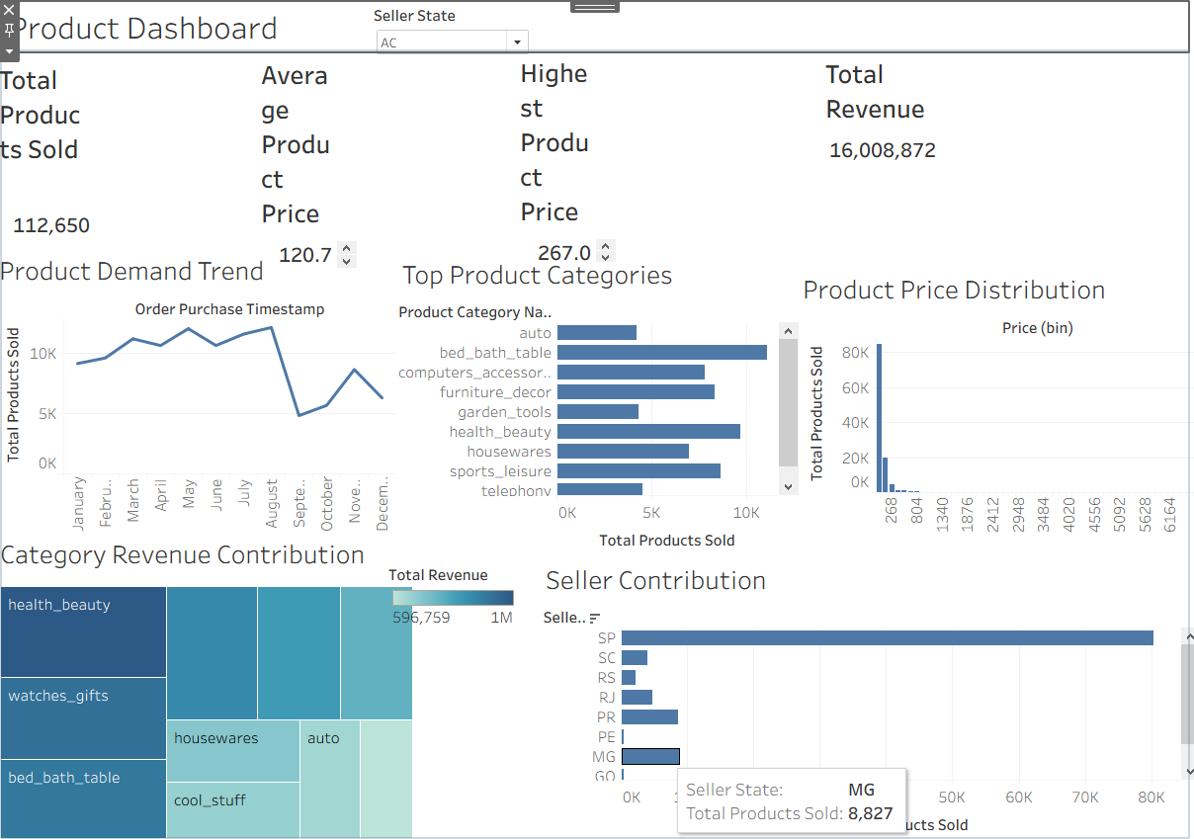

Section 10: Conclusion

10.1 Overall Project Summary
This project successfully implemented a complete end-to-end Data Warehouse and Business Intelligence solution for the Olist Brazilian E-Commerce platform. Starting from nine raw operational CSV files, the project progressed through database design, dimensional modelling, ETL processing, SQL analytics, and finally interactive dashboard development in both Power BI and Tableau.

10.2 Key Insights Generated

Revenue and Sales
- Total revenue of R$16.01M was generated across the dataset period with consistent growth through 2017-2018.
- November 2017 was the single highest revenue month, driven by Black Friday and holiday season purchases.
- Credit card payments dominate at 78% of all transactions, with high installment usage (avg 2.85 installments) indicating price-sensitive customers.
- Q4 revenue is nearly 2x Q1 revenue, confirming strong seasonality that should drive inventory and staffing planning.

Customer Behaviour
- 96,096 unique customers placed orders but 97% only ordered once, indicating near-zero retention and a massive opportunity for repeat purchase strategies.
- São Paulo state holds 43% of all customers and generates approximately 40% of all revenue, creating geographic concentration risk.
- Customer satisfaction is strong with 4.09 average review score and 59% of all reviews being 5-star ratings.
- 1-star reviews are the second largest group despite the high overall average, suggesting a polarised satisfaction pattern requiring attention.

Products and Inventory
- Health & beauty and bed & bath table are the top performing categories by both revenue and order volume.
- Product demand declines from July onwards across most categories, suggesting the need for mid-year promotional campaigns.
- SP sellers supply 75% of all products sold, creating significant supply chain concentration risk if São Paulo operations are disrupted.
- Products with more photos score higher in reviews, recommending a minimum 4-photo policy for all new listings.

Logistics and Operations
- 92.1% of orders were delivered on time, but the remaining 7.9% represents nearly 8,000 late deliveries impacting customer satisfaction.
- Northern states such as Roraima and Amapá have late delivery rates above 25%, driven by geographic remoteness and fewer carriers.
- Average delivery time of 12.5 days nationally could be reduced through regional fulfillment centres in underserved areas.

10.3 How the Solution Supports Decision Making
The Data Warehouse and dashboard solution enables data-driven decision making across multiple business functions:

Business Function | How Dashboards Support Decision Making
Executive Management | Overview dashboard provides single-page KPI summary for board-level reporting and period-over-period performance tracking
Sales & Revenue | Sales dashboard identifies peak periods, top cities, and installment patterns to optimise pricing and promotional timing
Marketing & Acquisition | Customer dashboard shows geographic concentration and acquisition trends to target underserved states
Product Management | Product dashboard reveals top categories, quality heatmaps, and price sweet spots to guide catalog decisions
Supply Chain & Logistics | Logistics metrics identify late delivery hotspots and freight cost drivers to optimise carrier contracts
Finance | Net revenue, installment analysis, and payment type breakdown support cash flow forecasting and credit risk assessment

10.4 Future Recommendations
- Implement a customer retention programme targeting the 97% of customers who only purchased once.
- Open regional fulfilment centres in the North and Northeast to reduce delivery times and late delivery rates.
- Introduce a minimum 4-photo requirement for product listings to improve review scores.
- Launch targeted Black Friday campaigns beginning in September to extend the November revenue peak.
- Develop seller quality metrics and incentive programmes to reduce geographic supply concentration in São Paulo.

10.5 Technical Achievements
- Successfully designed and implemented a complete star schema Data Warehouse with 9 dimension and fact tables.
- Created 16+ DAX measures and 6 calculated columns in Power BI for comprehensive KPI reporting.
- Built 4 interactive Power BI dashboards with synchronized slicers, navigator, and conditional formatting.
- Developed 3 Tableau dashboards with forecasting, heatmaps, treemaps, geographic maps, and dashboard actions.
- Applied professional enterprise color themes and layout standards consistent across both BI platforms.

